April 2013

good news flash

DUNLOP ZONE OPENS IN GHANA

Apollo Tyres South Africa (Pty) Ltd and Rana Motors in Ghana opened a new Dunlop Zone on 18th March 2013. The function was attended by Apollo Tyres CEO, Mr. Riaz Haffejee and Head of International Business, Mr. A. Govindram.
West Africa Tires Service a subsidiary of Rana Motors in collaboration with Apollo Tyres and Engen Ghana Limited have introduced the state-of-the-art tyre servicing concept, renowned for its quality services and high performance products.
This is the first Dunlop Zone to open in Ghana. Apollo Tyres opened its first North African Dunlop Zone in Nairobi Kenya in July 2012. The company envisages extending its international footprint throughout Africa and Latin America within the next five years.
Apollo Tyres is a wholly owned subsidiary of Apollo Tyres Limited of India with head offices in South Africa. It has as its core business, the manufacturing and distribution of tyres in South Africa and 32 other African countries.
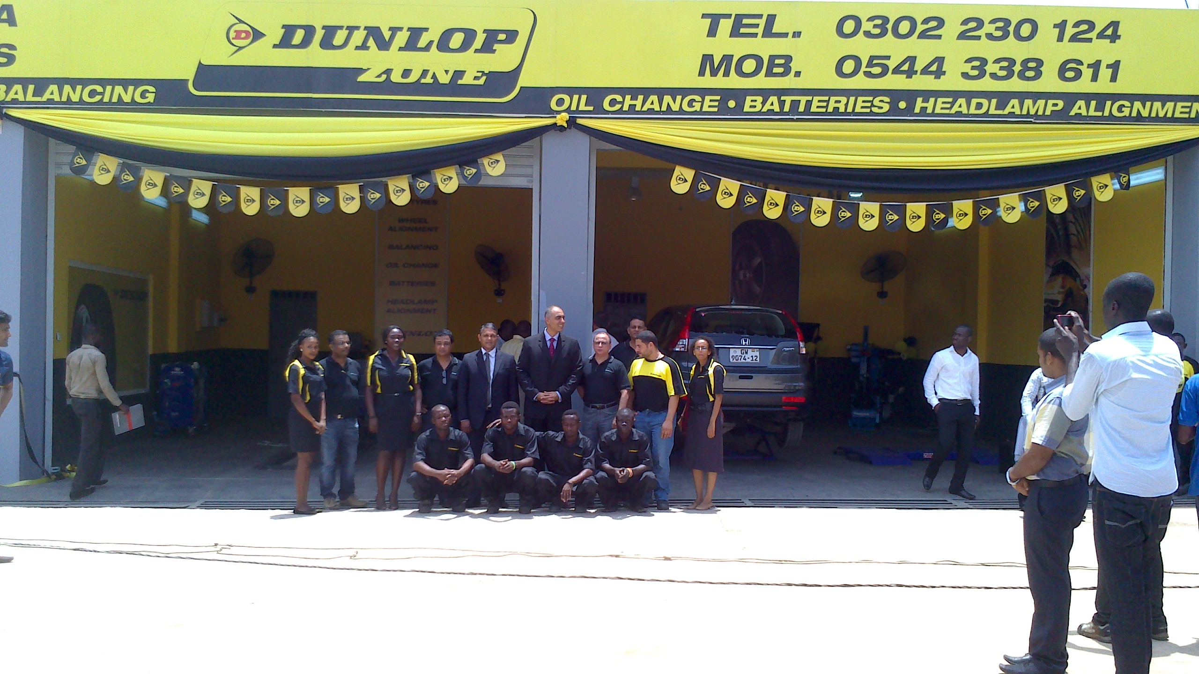
For further details contact:
BRONWEN BOWEY, +27 31 242 1453, bronwen.bowley@za.apollotyres.com
MICHELLE RAMKALAWAN, +27 31 1318, michelle.ramkalawan@za.apollotyres.com

About Apollo Tyres South Africa (Pty) Ltd
Apollo Tyres South Africa (ATSA) is a subsidiary of Apollo Tyres Ltd, a multinational tyre manufacturer with India, South Africa and Netherlands as if manufacturing locations. Headquartered out of Durban, South Africa, ATSA manufactures and sells high performance tyres for every motoring application. Dunlop is the foremost brand sold in 32 African countries. The company also has manufacturing facilities and distribution network in Zimbabwe.

Apollo Tyres South Africa (Pty) Ltd, 265 Sydney Road Congella, PO Box 925, Durban 4000, KwaZulu Natal, South Africa
T: +27 31 242 1111 F: +27 31 242 1605 apollotyres.com

