April 2013

good news flash

Dunlop Brand reintroduced into Nigerian Market

The Dunlop brand was reintroduced into the Nigerian market on March 19th 2013 by the Chief Executive Officer of Apollo Tyres South Africa, Mr. Riaz Haffejee in conjunction with Nigerian industry giant – Somotex who will act as Apollo Tyres’ distributor in the country. The event was attended by stakeholders in the transport industry.
Mr. Haffejee said the brand was given to Somotex on the strength of the company’s experience, and extensive network of distribution channels.
“We are fully committed to supporting Somotex in re-building the Dunlop brand in Nigeria and you can count on us when it comes to putting our full weight behind it. As you can see, Dunlop tyres coming into the market are backed with a warranty. This is a sure sign of our commitment to the brand internationally and we shall always keep our word. Our plan is to continually ensure that Nigeria’s iconic brand – Dunlop - is back on the wheels on Nigeria roads, ensuring safety, better performance and above all value for money,” he said.
The Managing Director of Somotex in Nigeria, Mr. Anil Mohinani stated that Somotex Nigeria Limited, a part of the Multinational Mohinani group is ready to re-position the brand back at the top of the Nigerian tyre market. Somotex will roll out the Dunlop brand into the Nigerian market through Somotex’s vast distribution network.
The Dunlop brand of tyres is produced at plants in South Africa using the latest technology in the industry and the best of designs that is in line with the new generation of cars, buses and trucks from the automotive industry, many of which are prescribed Original Equipment (OE), by global vehicle manufacturers.
Apollo Tyres South Africa envisages extending its international footprint throughout Africa and Latin America in the next few years as part of its tactical business strategy to grow its market presence.
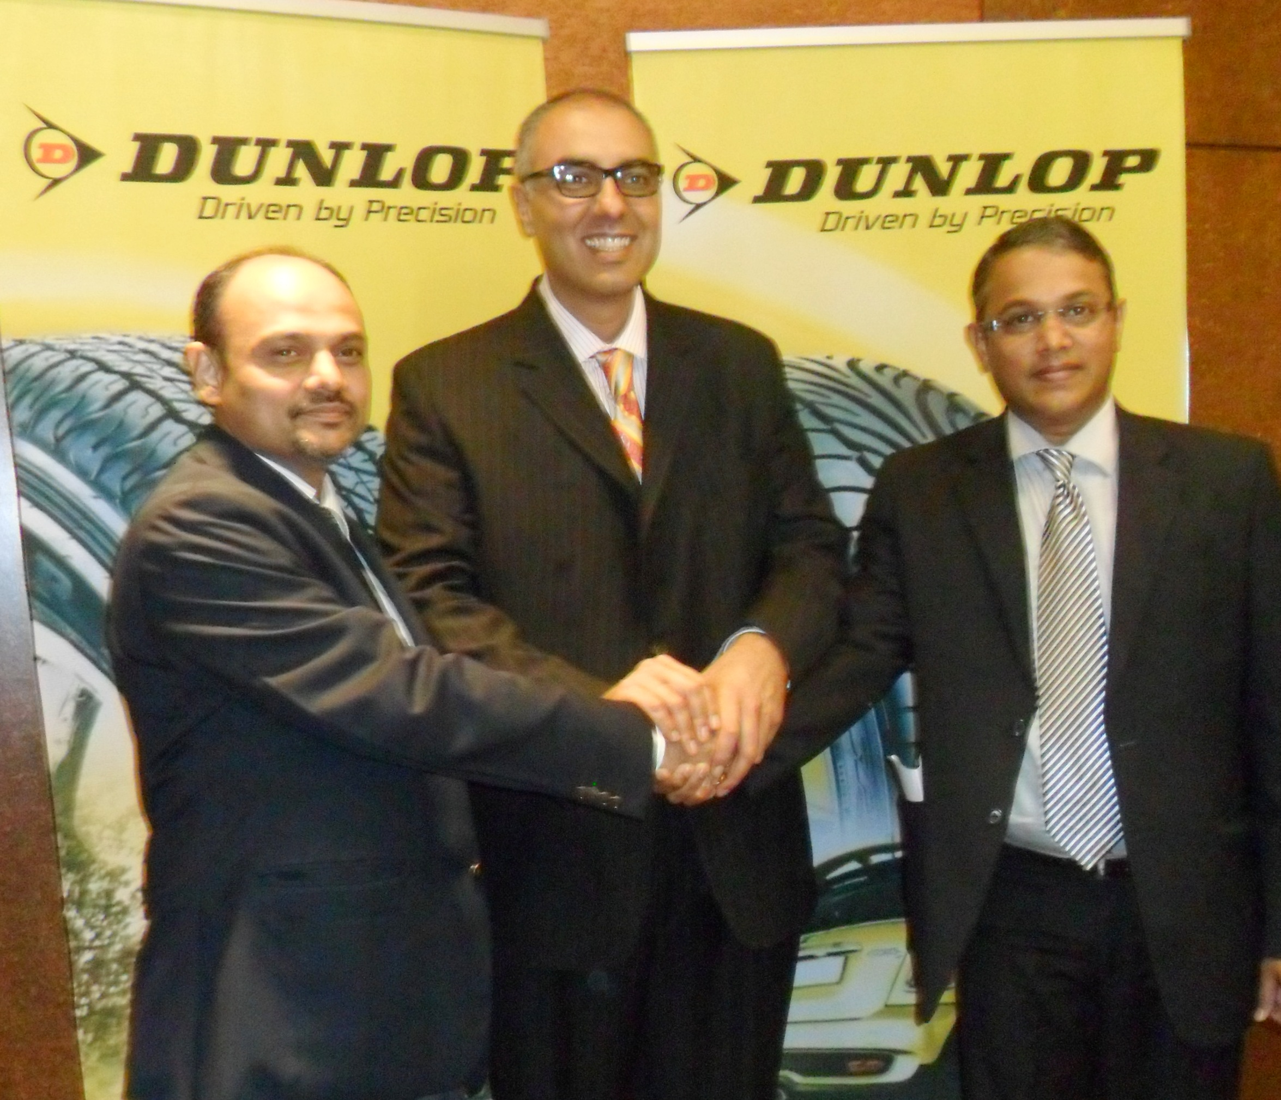

For further details contact:
BRONWEN BOWEY, +27 31 242 1453, bronwen.bowley@za.apollotyres.com
MICHELLE RAMKALAWAN, +27 31 242 1318, michelle.ramkalawan@za.apollotyres.com

About Apollo Tyres South Africa (Pty) Ltd
Apollo Tyres South Africa (ATSA) is a subsidiary of Apollo Tyres Ltd, a multinational tyre manufacturer with India, South Africa and Netherlands as if manufacturing locations. Headquartered out of Durban, South Africa, ATSA manufactures and sells high performance tyres for every motoring application. Dunlop is the foremost brand sold in 32 African countries. The company also has manufacturing facilities and distribution network in Zimbabwe.

Apollo Tyres South Africa (Pty) Ltd, 265 Sydney Road Congella, PO Box 925, Durban 4000, KwaZulu Natal, South Africa
T: +27 31 242 1111 F: +27 31 242 1605 apollotyres.com

